Angie Chen

GE1501 18472 SEC 10

Professor Hertz

27 November 2016

Assignment 10 Report: Secret

The importance of the protection of privacy has increased as the digital age of social media came into fruition. Encryption, a method to disguise information so that only people who know how to read it can understand. Computer programming like C++ has given people a platform to be able to encode text simply and ensure the exclusivity of knowledge.

This project runs a program that can encrypt or decrypt a piece of text entered upon specification. To organize my logic, I wrote a series of pseudocode displayed below before proceeding in prototyping in code.

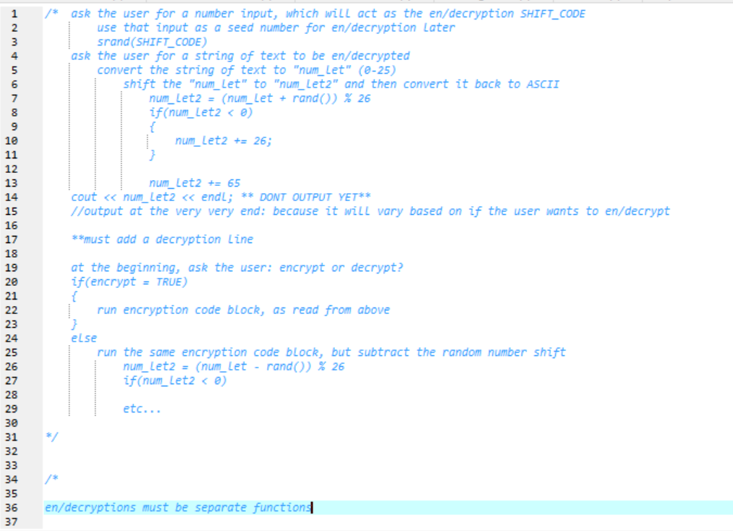

Upon further speculation, the pseudocode was not complete, since it did not truly specify the separate functions that were to store the encryption and decryption procedures. However, the series of prototyping below show parts of the working parts of the functions.

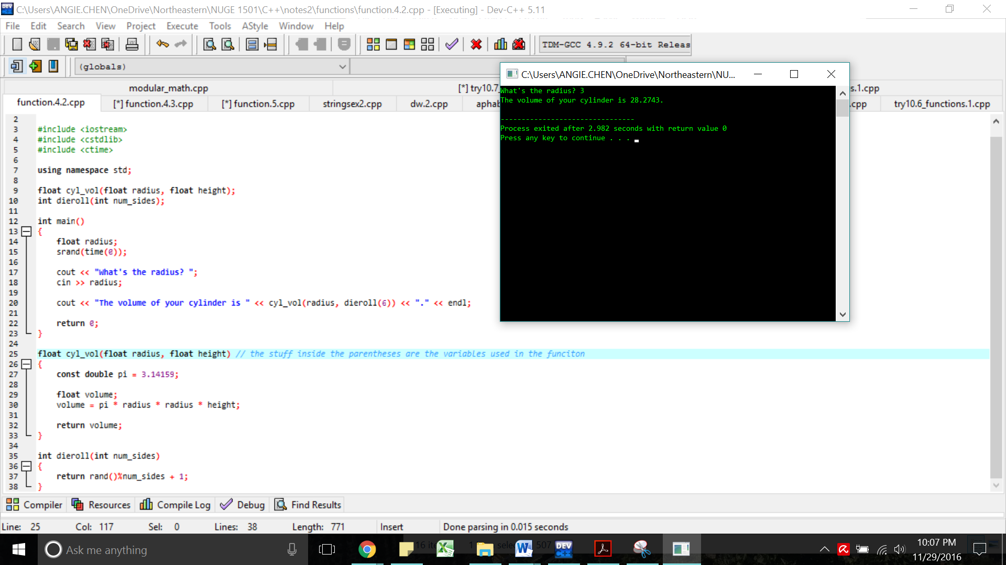

The above screenshot shows the workings of “cyl_vol”, a function that calculates the volume of a cylinder upon the input of an integer for the radius. This is an example of how I modeled my en/decryption functions.

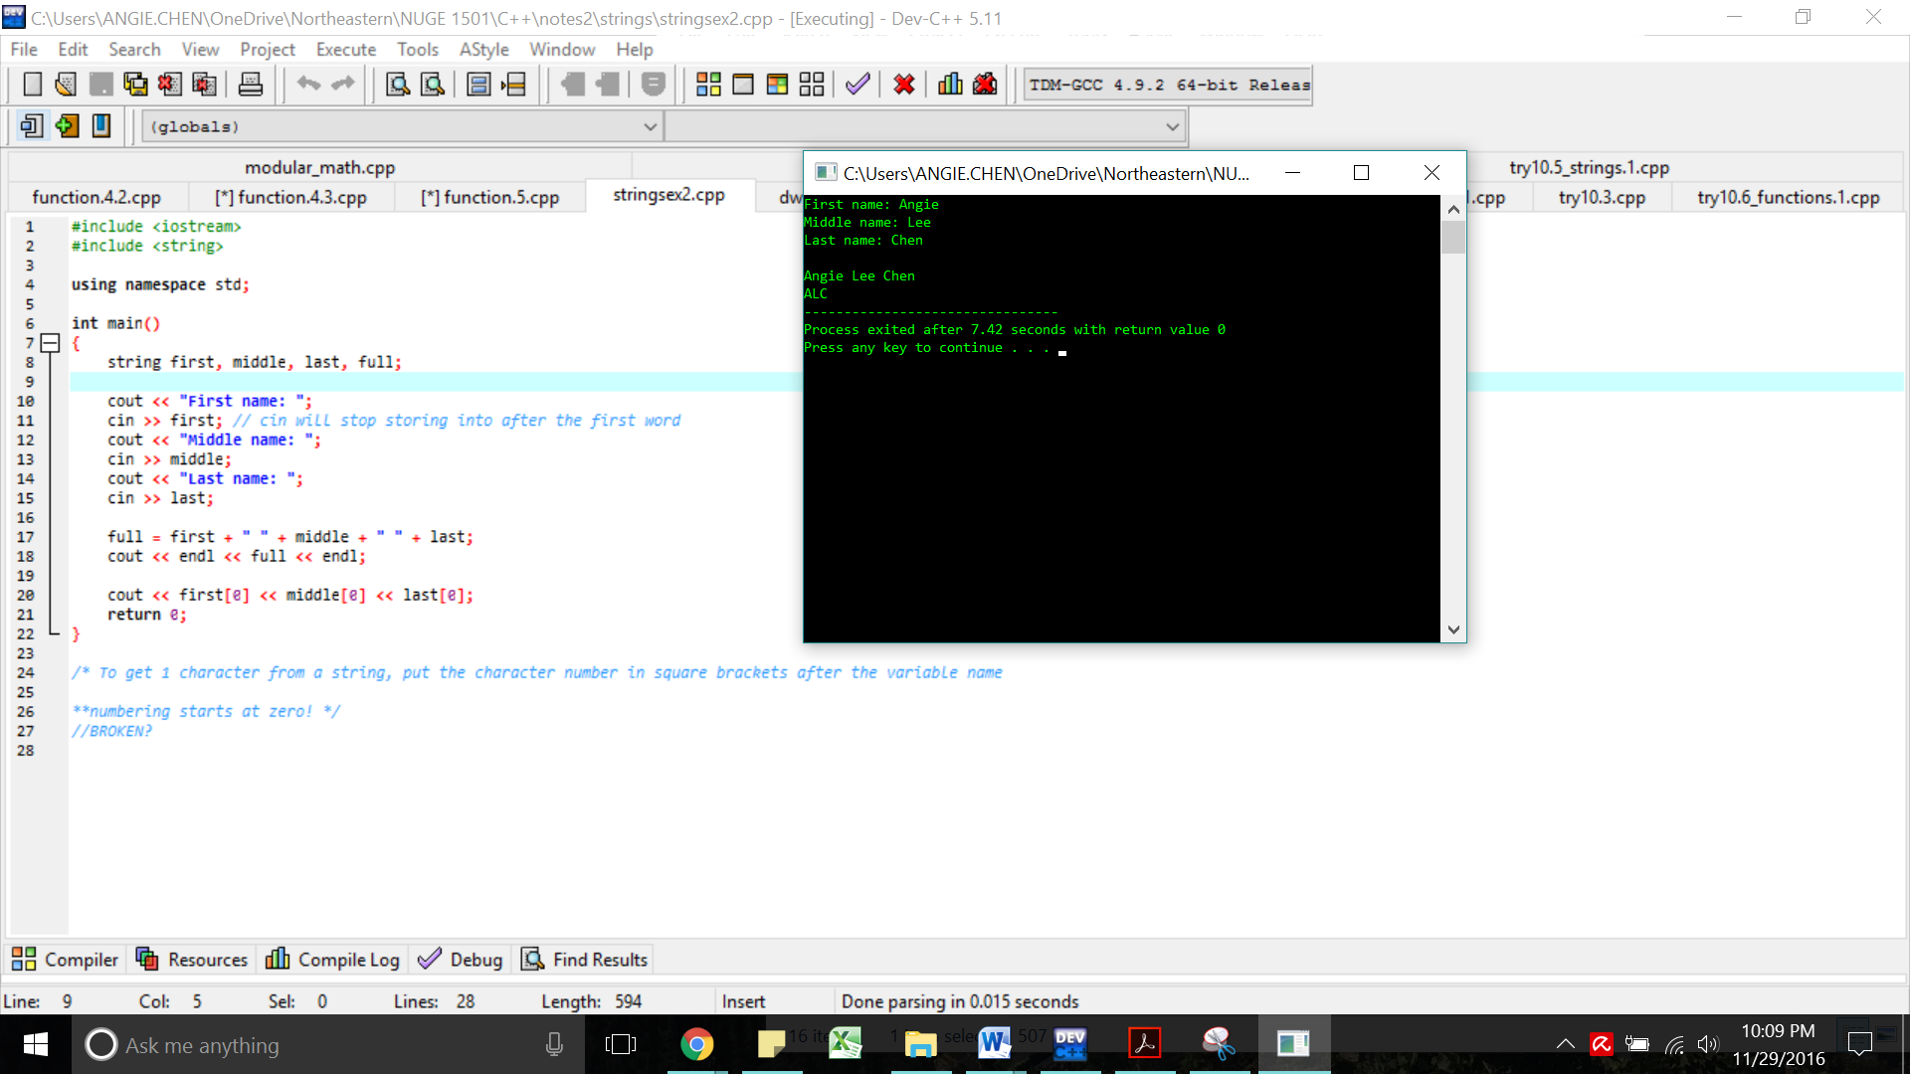

The strings library gives the user the ability to enter and store multiple characters of a text into a variable. These strings of characters are then used for encryption or decryption based on the shift code the user then enters into the console. Based on what the user specified the function (encryption or decryption), the program will use the shift code to shift each letter of the inputted text up or down the alphabet.

This method of encryption or decryption uses modular math and the ASCII values of C++. Capital letters inputted into the C++ console are interpreted as certain ASCII values that are first translated to 1-26, the order of the alphabet, shifted via the shift code input, then translated back into the respective ASCII value and reinterpreted through C++. Some shifted values may end up being greater 26 or less than 1, so in order to maintain the proper alphabet while en/decrypting, modular math, displayed in the figure below, is used.

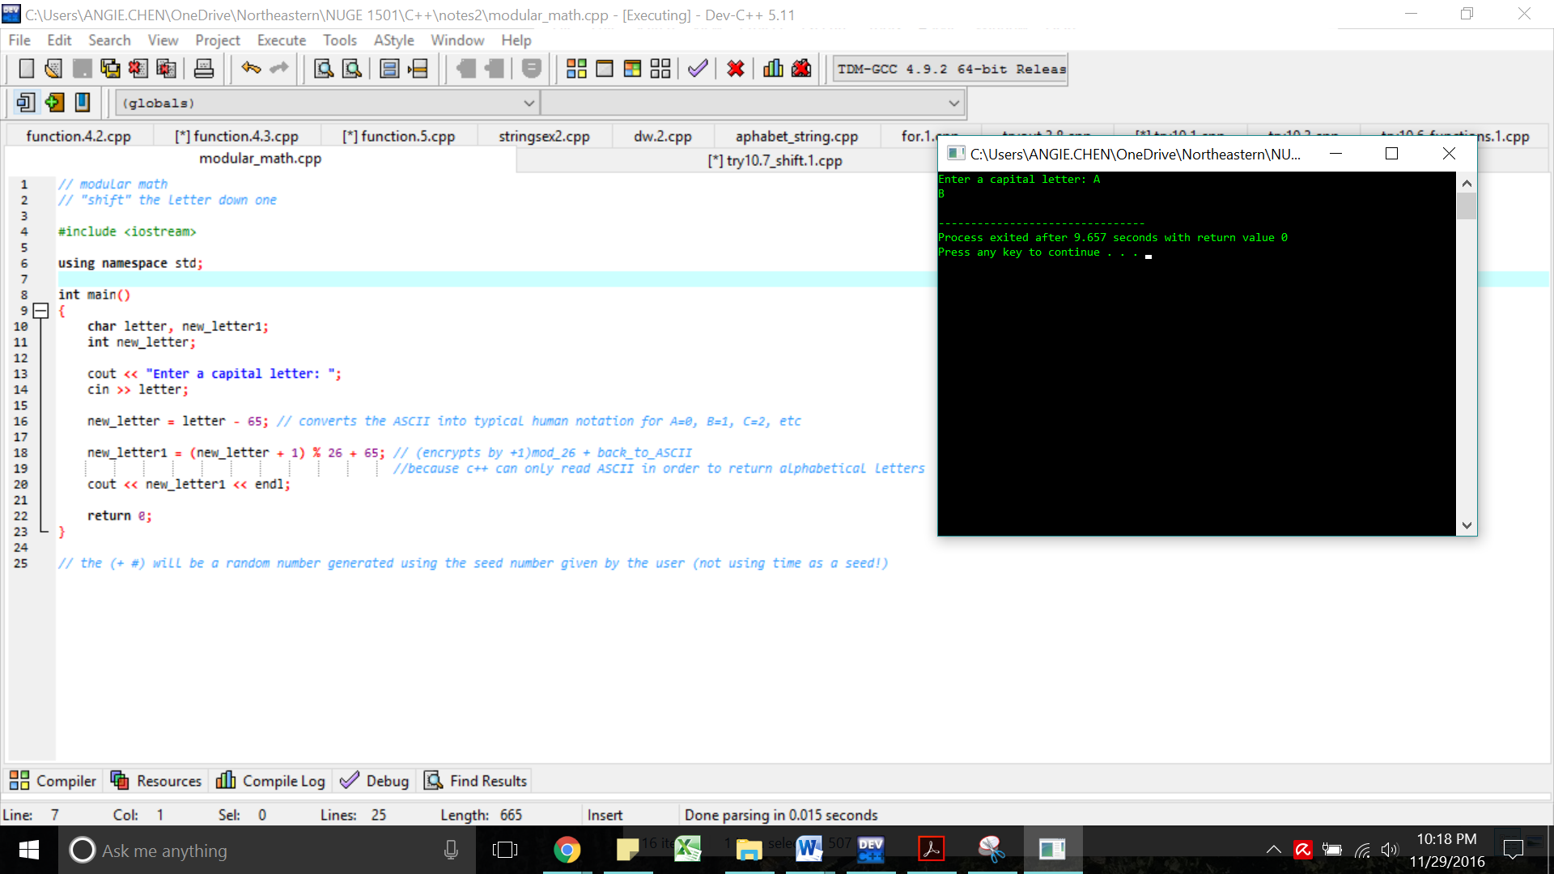

**Appendix**

#include <iostream>

#include <cstdlib>

#include <ctime>

#include <string>

using namespace std;

string encrypt(string text, int shift);

string decrypt(string text, int shift);

int main()

{

char enter;

string text;

int shift;

cout << "Enter text in capital letters: "; // "THISISASECRET" has 13 letters

cin >> text;

cout << "Enter shift code: ";

cin >> shift;

srand(shift);

do

{

cout << "Enter (E) for encryption, (D) for decryption: ";

cin >> enter;

if(enter == 'E')

// { cout << encrypt() << endl; } PUT the encrypt function here: encrypt(

// cout << encrypt

if(enter == 'D')

// { cout << decrypt() << endl; } PUT the decrypt function here

// cout << decrypt

}

while(enter != 'E' && enter != 'D');

return 0;

}

string encrypt(string text, int shift) // the stuff inside the parentheses are the variables used in this function

{

string encrypted; // send the text letter by letter into the en/decryption

return encrypted;

}

string decrypt(string text, int shift)

{

string decrypted;

return decrypted;

}